Assignment-1

1) What is SDLC?

A: SDLC means Software Development Life Cycle. It is step-by-step procedure to develop the software product by using the process for planning, implementation, testing, documentation, deployment, and ongoing maintenance.

2) What is Agile model/Methodology?

A: Agile model is a combination of iterative and Incremental model where the requirements are keeps on changing. It is a parallel procedure of development. Here we can deliver the piece of module to the customer in very small spam of time and very fast.

3) What is SRS (Software Requirement Specification) ?

A: SRS is a document that captures complete description about how the system is expected to perform or behaviour of the system to be developed.

4) What is OOPs?

A: Object Oriented Programming is a style of programming characterized by the identification of classes of objects closely linked with the methods with which they are associated.

5) Write basic concepts of OOPs?

A: There are 6 concepts.

1. Class
2. Object
3. Encapsulation
4. Inheritance
5. Polymorphism
6. Abstract

6 ) What is meant by Object?

A: Object is instances of Class.i.e to access all the properties of a class expect private data.

7) What is meant by class?

A: It is a collection of data member (variables) and member function (process, method) with its behaviour.

8) What is meant by Encapsulation?

A: It is nothing but wrapping of data into single unit i.e. private your data member or member function.

9) What is meant by Inheritance?

A: Properties of parent class extend into child class. The main purpose is to reusability and extendibility.

10) What is meant by Polymorphism?

A: Ability to take 1 name having different forms.

11) What is RDBMS?

A: Relational Data Base Management System (RDBMS) is a type of database that stores and provides access to data points that are related to one another.

12) What is SQL?

A: SQL (Structured Query Language) is a domain specific language for storing, manipulating and retrieving data stored in RDBMS.

13) What are the SQL Commands?

A: 1. DDL (Data Definition Language): CREATE, ALTER, DROP, TRUCATE, USE etc.…

2. DML (Data Manipulating Language): INSERT, UPDATE, DELETE

3. DQL (Data Query Language): SELECT

4. DCL/TCL (Data Control/Transactional Language): GRANT, REVOKE, COMMAND etc.…

14) Draw use case on online book shopping?

A:

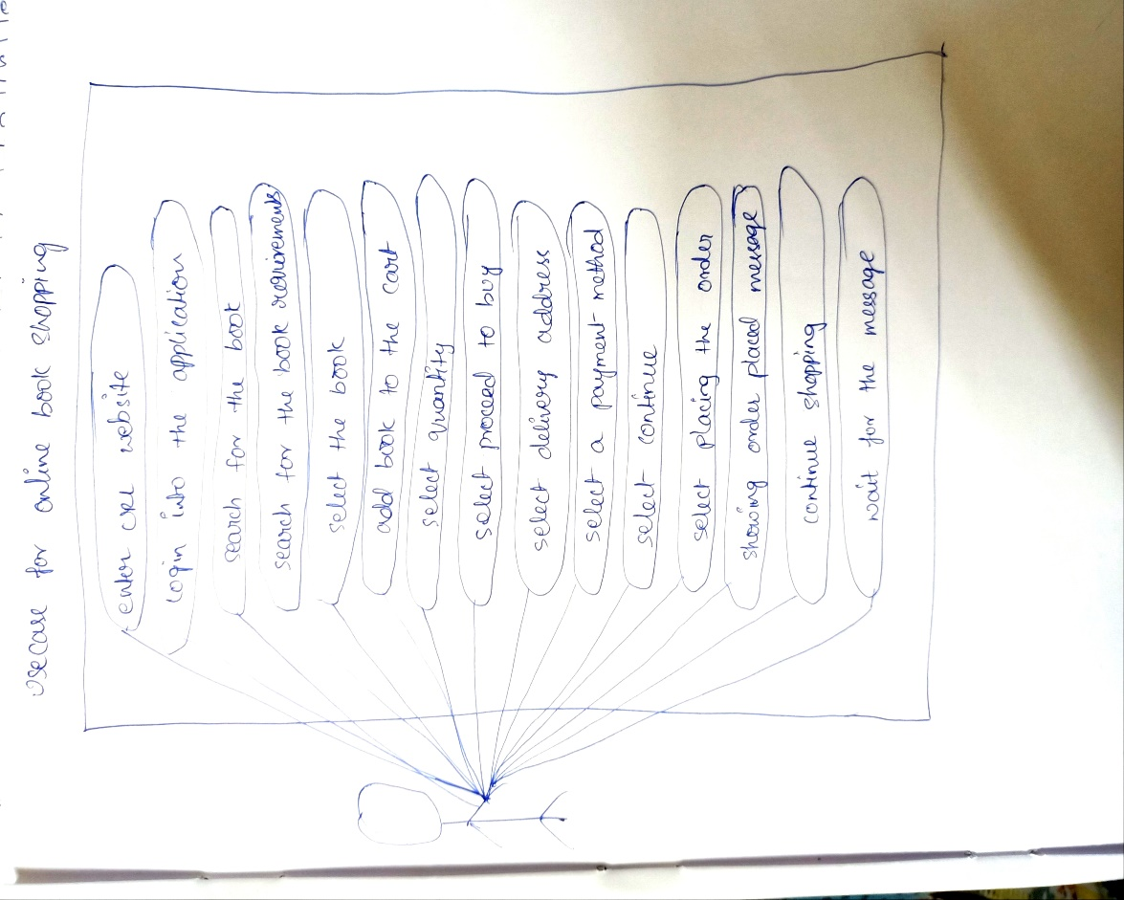

15) Draw use case on online bill payment system (Paytm)?

A: 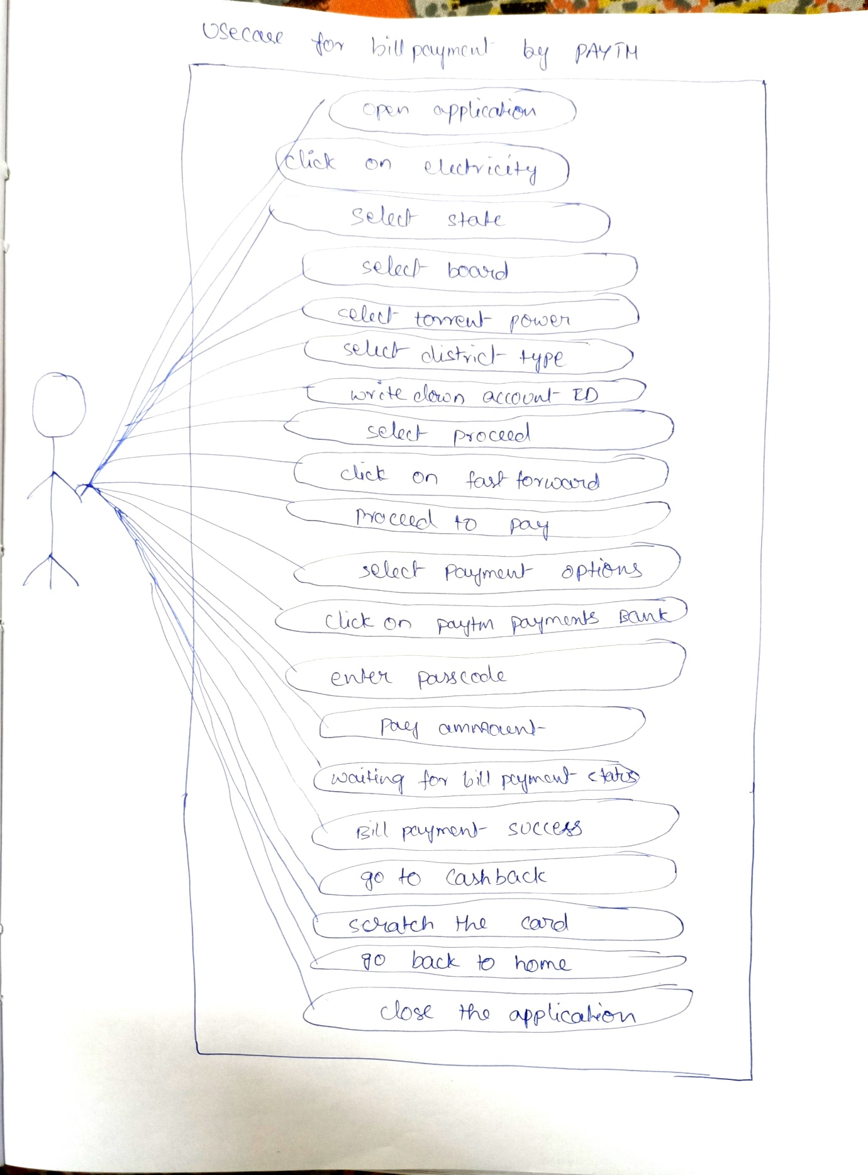

16) Write SDLC phases with basic introduction?

A: Requirement gathering/collection

Analysis

Design

Implementation/Development

Testing

Maintenance

Requirement Gathering/Collection: It is collection of documents from the customer.

Analysis: Here it identifies the risk, planning, etc.…

Design: It is the transformation of all requirements into detailed specifications.

Implementation/Development: Here the developer write the code. It is also called coding section.

Testing: Testing is nothing but quality with the customer requirements.

Maintenance: It identifies the issues using the software system in production.

17) Explain the phases in Waterfall model?

A:

Requirement collection: Requirement gathering/collection means collection of documents / software requirements from the customer. In this document we have several features, usage scenarios, requirement changing.

Analysis: This is the second phase in SDLC. It gathers documents from the customer , here we study of document and identifies the risk. It is used to how the system works and how it can be improved. It analysis the needs of the customer to ensure that the new system can meet their expectations or not.

Design: This is the third phase in SDLC. Design is nothing but transformation of all the requirements into detailed specifications.i.e how to implement by using logical algorithms, flow-charts, etc.…

Implementation: This is the fourth phase in SDLC. Here the developer develops code. It’s mainly focus on the Implementation of code and Critical Error Removals. It deals with the debugging, performance, quality, etc.…

Testing: This is fifth phase in SDLC. Testing means quality. It is done to verify the entire application working according to the customer requirement.

Maintenance: This is the final phase in SDLC. It comes after the deployment of the software into the field. It has software upgrades and repairs. It identifies the issues that are during the use of software application in production.

18) Write phases of spiral model?

A: There are four stages in spiral model

1. Planning: Determination of objectives, alternatives & constraints.
2. Risk analysis: Analysis of alternatives & identification/resolution of risks.
3. Engineering: Development of “next level” product.
4. Customer evaluation: Assessment of the results of engineering.

19) Write Agile manifesto Principals?

A: 1. Individual & Interaction

2. Working software

3. Customer collaboration

4. Responding to change

20) What is JOIN?

A: A JOIN clause is used to combine rows from two to more tables, based on a related column between them.

21) Write types of JOINs?

A: 1: Inner Join: Returns records that have matching values in both tables.

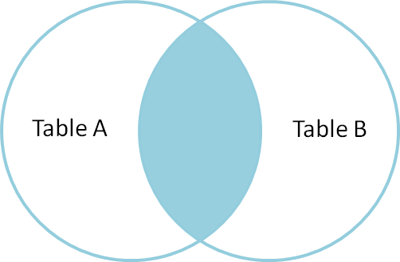

2. Left (outer) Join: Returns all records from the left table, and the matched records from the right table.

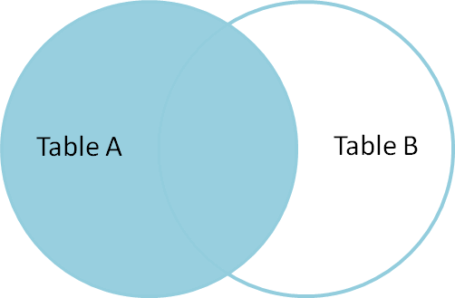

3. Right (outer) Join: Returns all records from the right table, and the matched records from the left table.

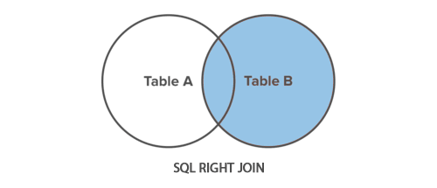

4. Full (outer) Join: Returns all record when there is a match in either left or right table.

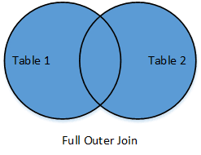

22) Explain working methodology of Agile model and also write props and cons?

A: Agile model is a combination of iterative and Incremental model where the requirements are keeps on changing. It is a parallel procedure of development. Here we can deliver the piece of module to the customer in very small spam of time and very fast.

Props:

* Promotes team work&cross work.
* Resource requirement are minimum.
* Delivers early partial working solutions.
* Reduces risk.
* Easily adopts the late change requirement.

Cons:

* Management is more complex.
* Not suitable for small projects.
* End of the project may not be known.
* Due to customer interaction, so if the customer is not clear, team can be driven in the wrong direction.

23) Draw use case on online shopping product using COD?

A: 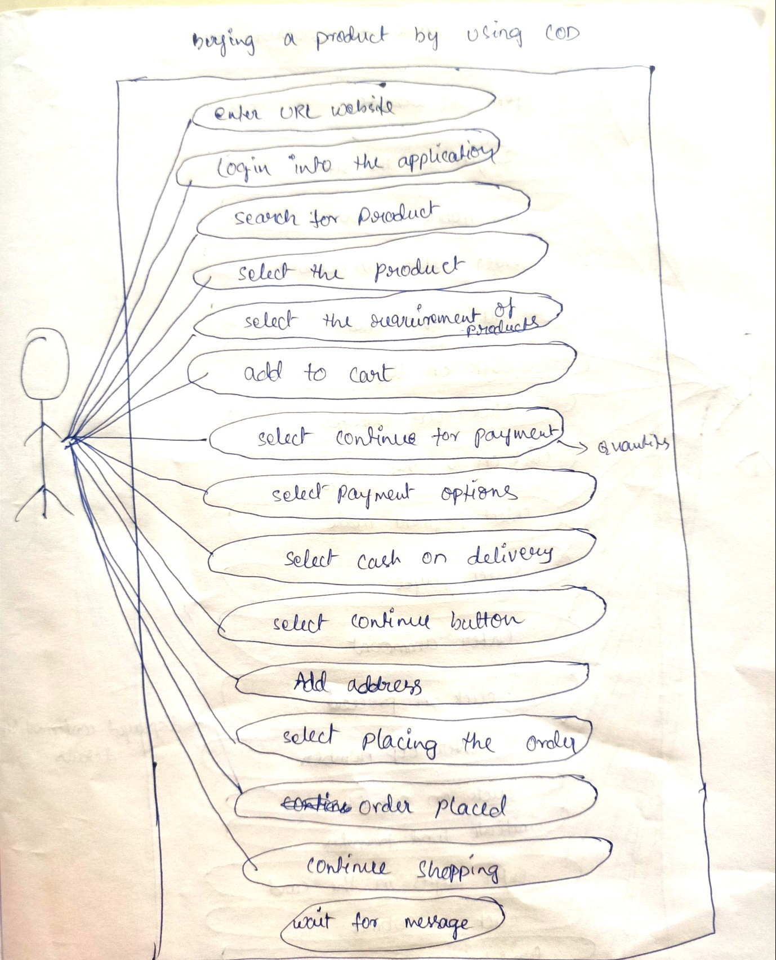

24) Draw use case on online shopping product using payment gateway?

A: 